Name : Hrujuta Gitay
Roll no.: 65
Class : BE B ENTC

Code:

<!DOCTYPE html>
<html lang="en">
<head>
<meta charset="UTF-8">
<meta name="viewport" content="width=device-width, ini al-scale=1.0">
< tle>Currency Converter</ tle>
<style> body {
font-family: Arial, sans-serif;
background: linear-gradient(135deg, #6dd5fa, #2980b9); color: #fff; display: flex; jus fy-content: center; align-items: center; height: 100vh; margin: 0;
}
.container {
background-color: rgba(0, 0, 0, 0.2); padding: 30px; border-radius: 10px;
box-shadow: 0px 4px 10px rgba(0, 0, 0, 0.3);
width: 300px;
text-align: center;
} h2 {
margin-bo om: 20px; color: #f1f1f1;
}
input, select, bu on { width: 90%; padding: 10px; margin: 10px 0; border-radius: 5px; border: none;
outline: none;
}
bu on {
background-color: #27ae60;
color: white; font-weight: bold;
cursor: pointer;
}
bu on:hover {
background-color: #18402E;
}
#result { margin-top: 15px; font-size: 18px; font-weight: bold;
}
</style>
</head>
<body>
<div class="container">
<h2>곊곋곌곍 Currency Converter</h2>
<input type="number" id="amount" placeholder="Enter amount" required>
<select id="fromCurrency">
<op on value="USD">USD</op on>
<op on value="EUR">EUR</op on> <op on value="INR">INR</op on>
<op on value="GBP">GBP</op on>
<op on value="JPY">JPY</op on>
</select>
<select id="toCurrency">
<op on value="INR">INR</op on>
<op on value="USD">USD</op on>
<op on value="EUR">EUR</op on> <op on value="GBP">GBP</op on>
<op on value="JPY">JPY</op on>
</select>
<bu on onclick="convertCurrency()">Convert</bu on>
<div id="result"></div>
</div>
<script>
async func on convertCurrency() { const amount = parseFloat(document.getElementById("amount").value); const from = document.getElementById("fromCurrency").value; const to = document.getElementById("toCurrency").value; const resultDiv = document.getElementById("result");

if (isNaN(amount) || amount <= 0) {
resultDiv.innerHTML = "Please enter a valid amount."; return;
} try {
const response = await fetch(`h ps://api.exchangerate-api.com/v4/latest/${from}`); const data = await response.json(); const rate = data.rates[to];
const converted = (amount * rate).toFixed(2); resultDiv.innerHTML = `${amount} ${from} = <br><strong>${converted} ${to}</strong>`;
} catch (error) {
resultDiv.innerHTML = "Error fetching exchange rates.";
}
}
</script>
</body>
</html>

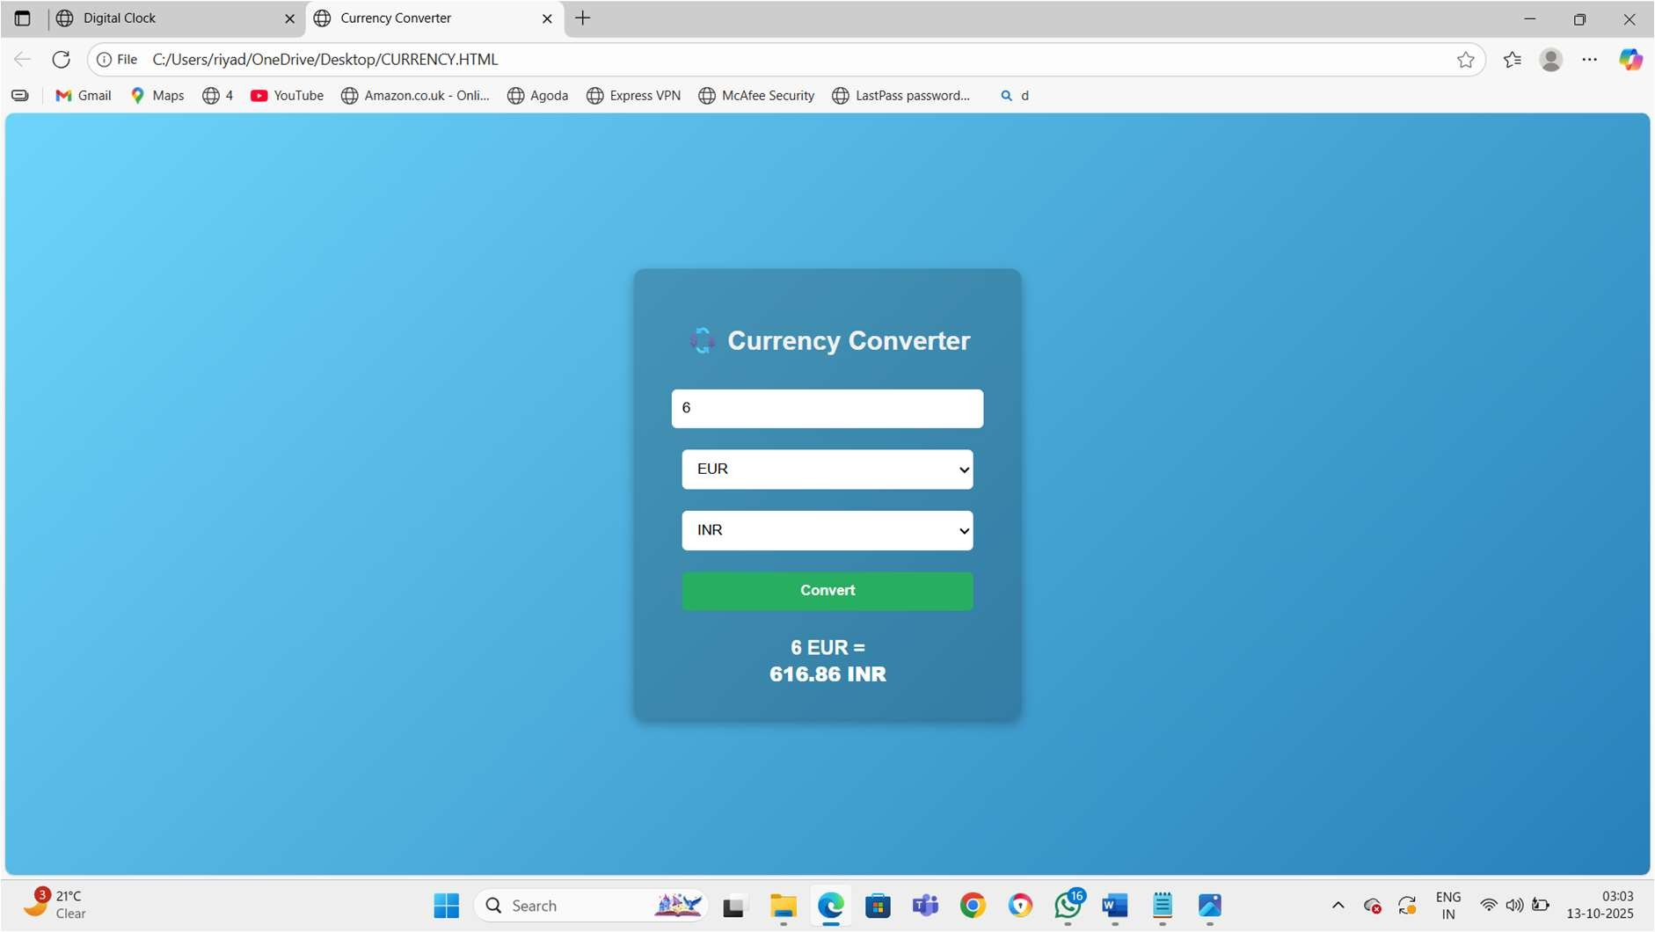
Output:

